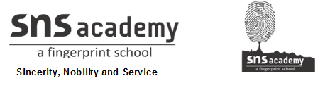
Marks obtained:

Total:
30
MONTHLY TEST FEBRUARY-2020
Name: ____________________________
Grade: I Section___
Subject: EVS
Date: 17.02.2020
Time: 1 Hour

I. Choose the best answer. (6X1=6)
1. We need ___________ to breathe.
a) water b) air c) food
2. Which of the following does not have air in it?
a) book b) balloon c) ball
3. We should wash our hands with ____________ after using toilet.
a) soap b) oil c) milk
4. Lion is a ____________ animal.
a) water b) land c) both land and water
5. Hooves are found in the legs of _____________________.
a) goat b) cat c) tiger
6. Which is the largest animal in the world?
a) blue whale b) giraffe c) elephant

II. Fill in the blanks. (4X1=4)
7 .Moving air is called_____________.
8. Air has no colour and______________.
9. We have to brush _____________ times a day.
10. Wild animals live in the _______________.
III. Match the following. (5X1=5)
11. monkey sea
12. octopus tree
13. trunk polar bear
14. fur horse
15. hooves elephant
IV. State whether the statements are true or false. (5x1=5)
16. We cannot see air.
17. Sailboat needs air to move.
18. Germs are harmless.
19. Bathing helps to keep our body clean.
20. Crocodile lives on land and in water.
V. Identify the picture. (5X1=5)
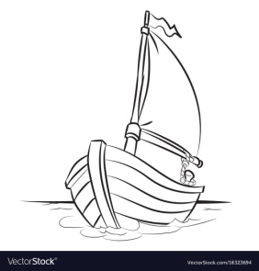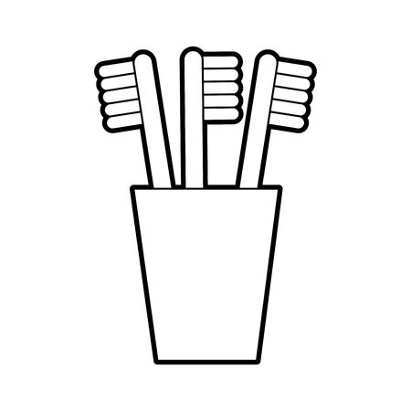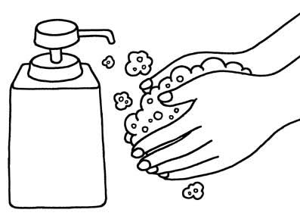
21._______________ 22.______________ 23.________________
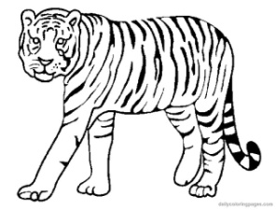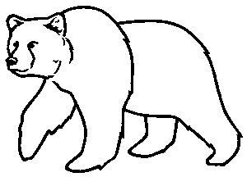
24 ___________________ 25._______________________

VI. Draw your favourite pet and label its parts. (5)

